**Sprint 1 Report,**

**Pantry Pal**

**07/10/2023**

**Actions to stop doing:**

There are no actions to stop doing. For this sprint we were able to accomplish all of our user stories and were satisfied with our work. Everyone was able to make the meetings and check-ins we had.

Satisfied, and completed all the user stories for the sprint and people can make the meeting session.

**Actions to start doing:**

Each member of the team should make sure to provide daily updates to the team on what they are doing and follow having a team standup where everyone can update the scrum board as well.

Teams should update more on what they are doing, preferably every day, and follow standup for 15 mins to update the board.

**Actions to keep doing:**

As a team, what allowed us to complete all of our user stories was meeting at least twice a week for sprint planning and sprint review and also using our discord server to communicate and track progress.

What worked was meeting at least twice a week for sprint planning and sprint review and keep track of stuff on discord server.

**Work completed/not completed:**

Completed User stories:

* As a user, I want a user interface to input my ingredients. **Total 12 hours**
  + Design Mockups: UI/UX designer will create mockups of our application. Although Streamlit provides basic layouts, having a clear idea will guide our development.
  + Setup Streamlit Environment: Set up a new Streamlit project, establish the necessary Python environment, and ensure Streamlit runs correctly.
  + Create Input Form: Build a form using Streamlit's capabilities where users can input the ingredients they have.
  + Make API Request: Write a function to take the user's input, make a GET request to our Flask API, and receive the recipe recommendations.
* As a user, I want a variety of recipes based on the ingredients I listed **Total: 3hrs**
  + Identify Target Websites: Research and identify the websites we want to scrape for our recipes.
  + Setup Scraping Environment: Set up a Python environment suitable for web scraping, including installing necessary libraries such as BeautifulSoup and requests.
  + Design Scraping Logic: create a function or script that fetches a webpage and extracts the necessary data (e.g., recipe names and their ingredients). Work with ML team to see what data schema to use
  + Initial Scraping: Perform an initial scrape to see if we can successfully extract the data we need.
* As a user, I want to receive recipes recommendations without having to build the ml model myself **Total 2hrs**
  + Setup Flask Environment: Set up a new Flask project with the necessary Python environment, install necessary libraries, and ensure Flask runs correctly.
  + Design API Structure: Decide on the API's structure. Define the routes and the data each route will receive and return.
  + Implement 'recipes' Endpoint: Develop a GET endpoint that accepts a list of ingredients as input and returns placeholder data.
* As a user, I want to receive relevant recipe recommendations that can be made with the current ingredients that I have. **Total 11hrs**
  + Define csv table layout: to figure out what preprocessing needs to be done between scraping and creating the model
  + Preprocess the data for model: lemmatize words, get rid of unnecessary adjectives, remove stop words. **3 hours**
  + Use word2vec embeddings to create a model: finds which ingredients best match each other. **7 hours**
  + Use KNN: to find which are the n most relevant recipes
  + Use tf-idf: to find the most significant ingredients in a recipe or rare ingredients

Not completed user stories: None

**Work completion rate:**

* 0 user stories completed prior to the sprint
* 4 total user stories completed during the sprint
* 28 ideal work hours completed
* 5-day sprint

**Board initial (before TA recommended Jira):**

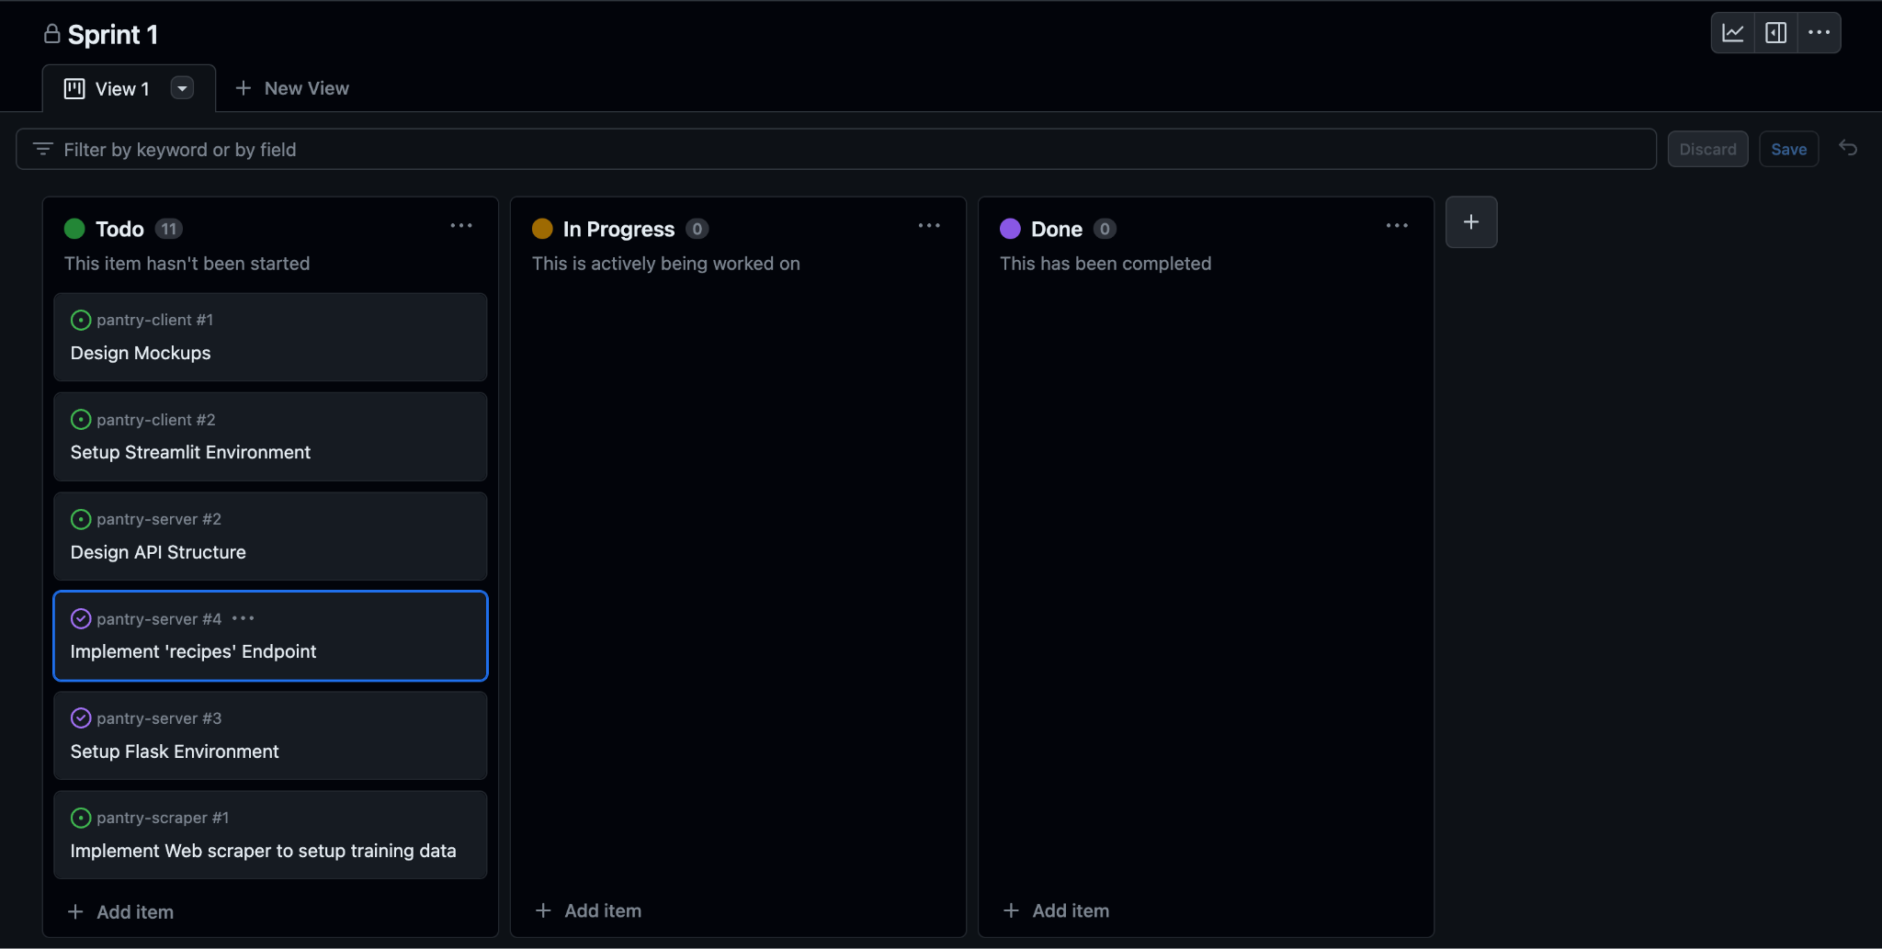

**Board after:**

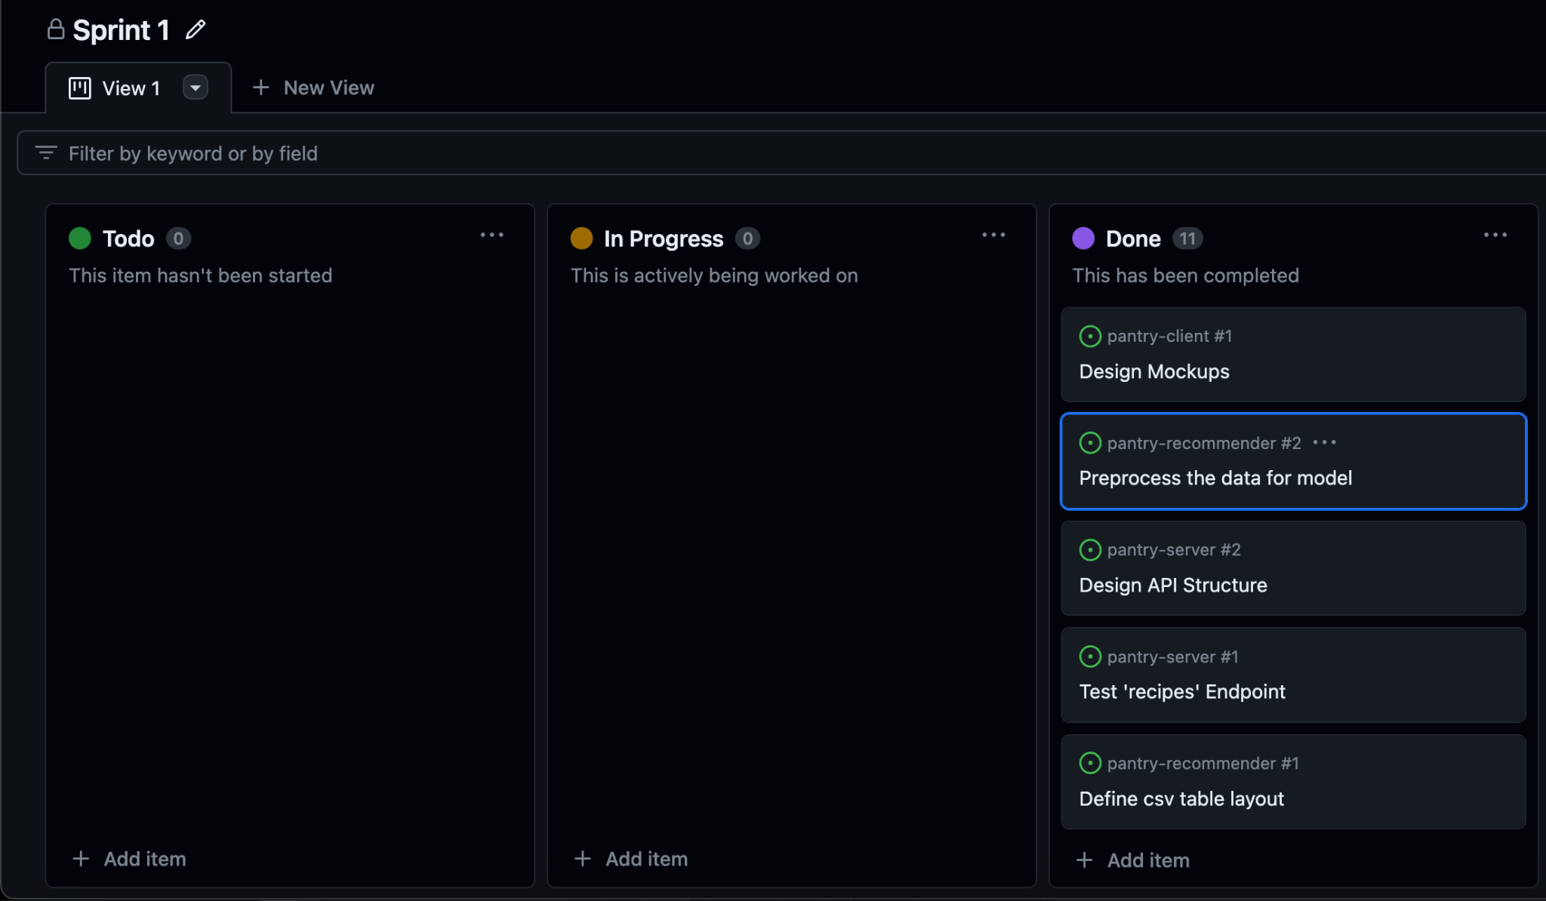

**Burn-up Report:**

